Information Visualization Fall 2008

Usability Evaluation of TouchGraph Google and TouchGraph Amazon

By Kelli Staley
December 2008

Usability Evaluation of TouchGraph Google and TouchGraph Amazon

- Introduction
- Hypothesis

- Brief overview of TouchGraph Interfaces

- User Selection

- Design of the Usability Study

- Execution of Usability Study

- User Experience

- Usability Findings

- Unexpected Findings

- Lessons Learned

- Conclusions

- User Feedback

  - Introduction
In this evaluation project, two variations on the TouchGraph browser were chosen for evaluation. User studies were conducted in order to evaluate the interface and were based upon concepts of heuristic evaluation. The usability study was intended to discover aspects of TouchGraph that need improvement, and reveal issues encountered by users experiencing their first example of search results presented in an information visualization format.
This usability study focuses upon the users’ ability to adapt to a completely new interface and the degree of discovery and exploration undertaken as they complete assigned tasks.
TouchGraph Google was chosen for evaluation of general web results, and TouchGraph Amazon was chosen for comparison of books and movies. Multiple products were chosen to allow users to form comparisons between the two. A third variation, TouchGraph Facebook was not included in this study, as most of the participants did not have Facebook accounts, and TouchGraph Facebook requires users to login to their account to create visualizations.
  - Hypothesis
Before beginning the evaluation project, it was hypothesized that:
- Users would be surprised by the new interface.
- Users would explore the interface.
- Users would be able to discern relationships between websites presented in the visualization.
- Users would find it easier to discern relationships in TouchGraph Amazon than TouchGraph Google due to their familiarity with the content of search terms selected.
- Experience gained in TouchGraph Google would transfer to TouchGraph Amazon and users would increase their success rate.
- Users would view the help section.
- Users would successfully launch websites from the TouchGraph interfaces.
  - Brief Overview of TouchGraph Interfaces
Searches in the TouchGraph Google Browser use the results from a Google search to allow users to reveal “the network of connectivity between websites, as reported by Google's database of related sites” (TouchGraph: Products: Google Browser), and TouchGraph Amazon uses information from Amazon.com to allow users to “Explore related books or albums, see how similar items form clusters around common subjects, and discover how the clusters themselves are connected within the information space” (TouchGraph: Products: Amazon Browser).
Information is presented in a graphical format with an item at the center with branches or nodes leading to related sites or items. This makes it easy to see relationships between related sites, and browse similar concepts (figure 1).
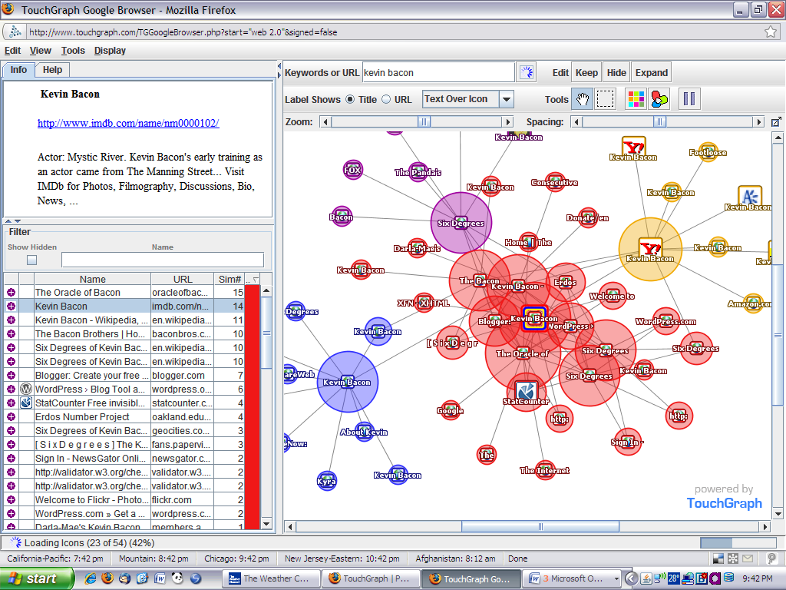
Figure 1
Individual clusters may be expanded or hidden to free up screen space to explore other areas in greater depth. Clusters are color coded to visually separate them from their surrounding clusters.
The TouchGraph Amazon interface features cover art from the books, movies, etc., on the clusters and nodes (figure 2).
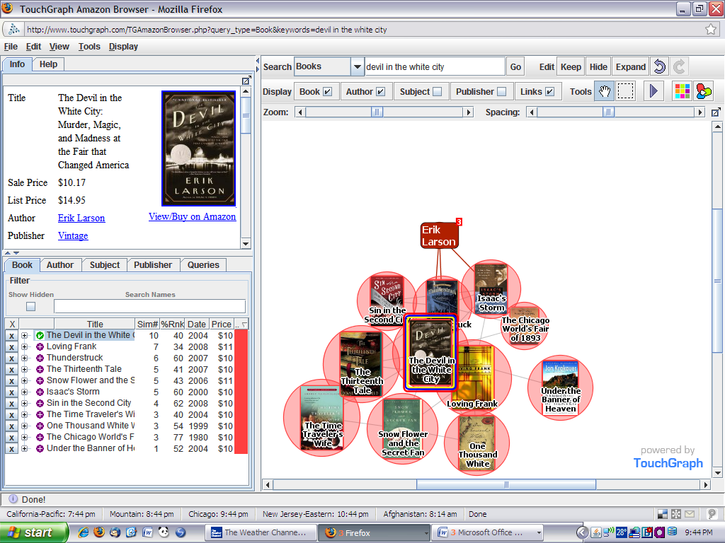
Figure 2
  - User Selection
Five users were recruited whom had varying levels of Internet experience. A sample size of five was chosen based upon research indicating that 5 users will discover 85% of errors, and larger sample sizes result in diminishing returns (Hudson, 2001). Users were purposely chosen from outside the library science or information science community to ensure they had not previously been exposed to TouchGraph interfaces. Users’ full time jobs include firefighters and a retired banker, all hold additional part-time jobs as firefighters. Two of the five users failed repeatedly to keep their appointments, and were removed from the study.
  - Design of the Usability Study
The usability study was designed to have seven brief sections. A combination of survey and tasks with observation was used to collect data. Tasks and survey questions were designed to touch upon aspects of Nielsen’s Heuristics for User Interface Design (Nielsen, 2005).
Surveys were constructed in SurveyMonkey (http://www.surveymonkey.com) chosen for the ease of use and ability to compile and analyze results. Concepts and some details during the design and actual execution of the usability study were based upon the lectures of Brenda Reeb of University of Rochester Libraries (Reeb, 2007). I attended one of her presentations in 2007, and based portions of this study upon that lecture. Survey response choices for multiple choice and ranking questions were randomized to reduce bias in responses.
- Introduction.
A prewritten script was developed to read to each user to ensure each user received the same information prior to the evaluation (see Appendix A for the script).
Each user signed the Informed Consent Form (see Appendixes B, C and D for the signed informed consent forms).
- Pre-Usability Survey
Users completed a brief survey about their prior Internet experience (see Appendix E for the survey questions and results).
- User Evaluation of TouchGraph Google
Users were presented with a list of tasks to complete in TouchGraph Google (see Appendix F for the list of tasks).
- Post-Evaluation Survey about TouchGraph Google
Immediately following the completion of the evaluation tasks, users completed a survey about their TouchGraph Google experience (see Appendix G for the survey questions and results).
- User Evaluation of TouchGraph Amazon
Users were presented with a list of tasks to complete in TouchGraph Amazon (see Appendix H for the list of tasks).
- Post-Evaluation Survey about TouchGraph Amazon
Immediately following the completion of the evaluation tasks, users completed a survey about their TouchGraph Amazon experience (see Appendix I for the survey questions and results).
- Evaluation Form/Exit Interview
Users were invited to provide any additional comments on the evaluation form (see Appendixes J, K and L for the users’ responses). Any further questions from the users would be answered and users would be provided with a $10 gift card as their compensation for participation.
  - Execution of the Usability Study
Users were provided with a laptop computer equipped with a mouse.
Users were provided with the Firefox 3.0.4 browser, and the URLs for the TouchGraph interfaces and surveys were loaded for them, so as not to introduce a barrier to accessing the interface. This also ensured the recording had been activated prior to the beginning of their interaction with the sites selected for evaluation. Additional toolbars (i.e. bookmarks toolbar, Google toolbar) and alerts (i.e. incoming email, weather advisory alerts) were hidden to reduce distractions.
One study took place at my residence; the other two took place at the classroom area of the fire station. All study participants had privacy during the observation and usability study. Study participants were isolated from each other prior to their participation to ensure they were not influencing each other, nor providing tips or impressions of the TouchGraph interfaces.
User evaluations of TouchGraph Google and TouchGraph Amazon were recorded using Camtasia. Screen capture was supplemented with webcam recordings to capture the participants’ expressions and for audio capture. Completion of the surveys was not recorded via screen capture or webcam.
Users were presented with one portion of the study at a time to keep them from being overwhelmed or from looking ahead at follow-up questions, which could influence their actions.
All participants completed the entire usability study within the allotted time of 45 minutes.
Participants were not given a tour or tutorial of the TouchGraph interfaces, as one of the goals of this evaluation focused on their initial experiences, and the degree of exploration they would embark upon when faced with a new interface. The only instruction given at the beginning of the study focused on participating in a user study.
  - User Experience
The Pre-Usability Survey collected data from the participants about their Internet experience. Two of the users were 55 years old; the third was 31 years old.
Participants indicated varying number of years of computer experience: 1-5 years, 11-15 years, and 26-30 years. It is interesting to note the participant with the most computer experience was the retired banker, but this experience is not primarily on the Internet.
66.7% of the users indicated they have “average” computer experience, 33.3% rated themselves “below average.”
100% of the users indicated experience with Internet searching. 100% of the users rated their Internet experience as “average.” 66.7% of the users indicated they use a search engine “daily,” 33.3% of the users indicated they use a search engine “a few times per week.”
66.7% of the users prefer to “search” for information compared to 33.3% whom prefer to “browse.”

Users were asked which websites they had used (table 1). Data revealed the users had experience with a variety of interfaces for searching. Facebook results confirmed the decision to omit TouchGraph Facebook from the usability study, as the TouchGraph Facebook interface requires users to login to their Facebook account in order to use the visualization tool.
Google | 66.7%
Amazon | 33.3%
Facebook | 33.3%
MySpace | 100%
MSN | 100%
Yahoo | 100%
Kartoo | 0%
Grokker | 0%
TouchGraph | 0%
Table 1
None of the users had experience with visual search engines. None of the users had prior experience with TouchGraph.
Overall, the user experience reveals the study participants to be typical Internet users. Each had enough experience that they were familiar with using a mouse, using a keyboard, identifying URLs and using search boxes.
  - Usability Findings
Compilation of the study data revealed differences between user observation, reaction and verbal comments and their responses to the survey questions.
Behavior was consistent between TouchGraph Google and TouchGraph Amazon. If a user had difficulty with a task in TouchGraph Google, they also had the same difficulty in TouchGraph Amazon. Users spent less time looking around the screen when using TouchGraph Amazon, and seemed more relaxed and confident.
Survey scales listed below were ratings of 1-10, with 10 being the highest. Nielsen’s heuristic evaluation criteria are presented with the observations, survey responses, and overall evaluation (Nielsen).
Visibility of system status
Criteria: The system should always keep users informed about what is going on, through appropriate feedback within reasonable time.
Observed: Users questioned if the interface was still working.
Survey: Users responded with an average rating of 6 for TouchGraph Google, and an average rating of 6.67 for TouchGraph Amazon.
Overall evaluation: The initial page load was dramatic, but the progress indicator at the lower left of the screen was not significant enough to get the users’ attention.
Recommendation: Addition of an icon that signals completion of the initial page load, or make the progress indicator larger during the loading process.
Match between system and the real world
Criteria: The system should speak the users' language, with words, phrases and concepts familiar to the user, rather than system-oriented terms. Follow real-world conventions, making information appear in a natural and logical order.
Observed: 100% of users quickly identified the search box in TouchGraph Google. One user had difficulty in TouchGraph Amazon, but realized the error when there lacked a way to execute a search on his terms. 66.7% of users immediately recognized the blue underlined URL in the information pane as a link that could be left-clicked to launch a website. 100% were able to identify the zoom slider bar and use it easily. Users were frustrated by their attempts to click on items in the list view or the graph. Users questioned the significance of the colors of the clusters. One user commented that he thought the colors indicated the degree of relevance to the search term. He compared it to the game of “Hot and Cold.” Red circles were “hot” or more relevant, and blue circles were “cold” or less relevant. Although an incorrect assumption on the user’s part, it shows the diligence of his attempt to relate the colors to a real-world analogy.
Survey: Users responded with an average rating of 6.67 when asked if the interface was intuitive for both TouchGraph Google and TouchGraph Amazon.
Overall evaluation: General design conventions were followed: blue, underlined URLs, search box placement high on the page, a “go” button to execute the search, tools gathered into a single area, but some areas need improvement. Users were very frustrated by their attempts to launch websites from the graph or list view, and all were unsuccessful in those tasks.
Recommendation: Make it possible to left-click on an item in the graph pane to launch the URL. Make it possible to left-click on the URLs in list view to launch the websites, as the users thought this aspect was “broken.”

User control and freedom
Criteria: Users often choose system functions by mistake and will need a clearly marked "emergency exit" to leave the unwanted state without having to go through an extended dialogue. Support undo and redo.
Observed: One user was extremely frustrated by the lack of an undo function when he accidentally closed the browser window.
Survey: Users responded with an average rating of 5.34 for TouchGraph Google, and an average of 6.67 for TouchGraph Amazon when asked about the ability to go back to a previous screen.
Overall evaluation: TouchGraph lacks undo functionality, but the comments gathered in the study were actually directed at the internet browser’s lack of a prompt before closing. That particular user has his internet browser customized with an alert, and the computer used for testing did not have that feature activated.
Recommendation: Implement an undo and redo function, possibly with 2 or 3 steps, so users can step backward in increments.

Consistency and standards
Criteria: Users should not have to wonder whether different words, situations, or actions mean the same thing. Follow platform conventions.
Observed: Users understood the zoom and spacing tools, but were unclear on what the hand tool or selection box options were supposed to do. Users understood the familiar blue underlined URLs.
Survey: Users responded with an average rating of 6 for TouchGraph Google and an average rating of 5.67 for TouchGraph Amazon when asked about the effectiveness of the tools.
Overall evaluation: While hand tools and selection box tools are familiar to users of Photoshop or desktop publishing programs, the users in the study had not encountered these types of tools previously in their computer experience.
Recommendation: Provide alternate methods to inform users of the tool functions. For example, a pop-up tip could appear when the program is launched proving a brief tour of the tools. This should have an option to “no longer show at start-up” to meet expert users’ needs.

Error prevention
Criteria: Even better than good error messages is a careful design which prevents a problem from occurring in the first place. Either eliminate error-prone conditions or check for them and present users with a confirmation option before they commit to the action.
Observed: One user mistyped a search term, resulting in zero results. He did not realize the error, as there was no suggestion to correct the spelling. He eventually clicked in the search box again which somehow cleared the entry, and he typed it again only because it had disappeared. He was surprised it worked the second time.
Survey: Users responded with an average rating of 6 for TouchGraph Google and an average of 4 for TouchGraph Amazon when asked about the effectiveness of the help section, despite none of them actually viewed it.
Overall evaluation: TouchGraph needs effective error messages to help the user recover from mistakes. Also useful would be pop-up balloons similar to those in Microsoft Office which explain toolbar buttons, or tasks. A pop-up on mouse over the list could instruct users how to open those links.
Recommendation: Add meaningful error messages. A blank query should definitely advise users to type terms in the search box. Spelling suggestions are likely more difficult to implement, but would also be helpful.

Recognition rather than recall
Criteria: Minimize the user's memory load by making objects, actions, and options visible. The user should not have to remember information from one part of the dialogue to another. Instructions for use of the system should be visible or easily retrievable whenever appropriate.
Observed: Tools were easily located; methods for launching URLs were not easily visible. None of the users right-clicked their mouse on the graph to explore if other options or actions were available. Users seemed very comfortable with TouchGraph Amazon after using TouchGraph Google, as the interface was familiar, and they quickly completed the tasks for TouchGraph Amazon. Tools are always present on the screen.
Survey: Users responded with an average rating of 6.34 for Touch Graph Google and an average rating of 6.67 for TouchGraph Amazon when asked if the interface was easy to use. Users responded that TouchGraph Amazon was easier to use due to their exposure to TouchGraph Google.
Overall evaluation: Increased exposure makes this type of interface easier to use, but user comments indicated it needs better instructions.
Recommendations: Launch a tutorial or introduction upon the first visit to the site. Although searching is intuitive, manipulation and use of the results is unclear unless users read the help documentation.

Flexibility and efficiency of use
Criteria: Accelerators -- unseen by the novice user -- may often speed up the interaction for the expert user such that the system can cater to both inexperienced and experienced users. Allow users to tailor frequent actions.
This aspect was not evaluated in this study as the participants were all novice users.
Recommendations: Allow users to drag and resize portions of the screen (i.e. enlarge the graph window) and then save that as their default preference. Allow for saving of frequent search terms for research projects.
Aesthetic and minimalist design
Criteria: Dialogues should not contain information which is irrelevant or rarely needed. Every extra unit of information in a dialogue competes with the relevant units of information and diminishes their relative visibility.
Observed: Users felt the design was repetitious, with duplication between the information panel, list and graph. However, they felt it lacking in explanation of what they should do with the information presented.
Survey: User responses indicated they had difficulty in launching URLs, and understanding the use of color. One user indicated the interface had poor navigation.
Overall evaluation: Extraneous details are not present. Multiple panes with information seemed to overwhelm the users at first, and then most focused on a single area, ignoring what they felt was the duplicated information.
Recommendation: The list view seems redundant and counter-productive to the process, although some of the users in the study focused their attention here because they felt they did not understand the graph pane. Drop the list view in favor of an expanded area for the info pane to show details of items upon mouse-over.
Help users recognize, diagnose, and recover from errors
Criteria: Error messages should be expressed in plain language (no codes), precisely indicate the problem, and constructively suggest a solution.
Observed: Users clicked repeatedly in attempts to launch URLs. Misspellings did not produce an error message. Users did not encounter any error messages at all.
Survey: One user responded that the interface was not user friendly.
Overall evaluation: Lack of error messages, does not apply.
Recommendation: Add significant error messages. As mentioned above, the lack of error messages resulted in the user thinking there was a problem with the interface, not a user error when he executed a search with an empty search box.

Help and documentation
Criteria: Even though it is better if the system can be used without documentation, it may be necessary to provide help and documentation. Any such information should be easy to search, focused on the user's task, list concrete steps to be carried out, and not be too large.
Observed: None of the users clicked on the link to the help area, despite their failures at some attempted tasks.
Survey: Users responded with an average rating of 6 for TouchGraph Google and an average of 4 for TouchGraph Amazon when asked about the effectiveness of the help section, despite none of them actually viewed it.
Overall evaluation: No matter what information is contained in a help area, users must open it and read it to be effective. Despite their frustration, they still did not seek help, although one participant asked me questions, which he followed with “you probably cannot answer that” because of the instructions given at the beginning of the user study. I did not answer the questions.
Recommendation: This type of interface is completely new to average Internet users. It should provide an automatic introduction to the site and proper use of tools. The user must be remembered during the process. During various tasks, additional help tips could appear. Possible prompts could include common tasks such as “view this website,” “find more like this website,” etc.
  - Unexpected Findings
Data collected in the post-evaluation surveys revealed ratings for portions of the interface not tested by the users. All participants gave a rating to the help available in TouchGraph yet none of the users clicked into the help area. One user encountered the lack of significant error messages when he mistyped the search term and did not realize his error, yet he gave the help section a rating of 10 on a 1-10 scale.
One user had to be coaxed back to the TouchGraph Amazon interface after following a link and proceeding to attempt to complete the remaining tasks in the Amazon.com interface.
Users were consistently unsuccessful in completion of some tasks on the list, such as “expand your selected item.” None of the users even approached the “expand” button on the toolbar, nor did they click to expand in graph view.
All users ultimately asked if I had designed the TouchGraph interfaces. One asked at the beginning, one in following the TouchGraph Google tasks, and the third at the end of the study. I suspect if I had been the designer, they may have been less honest in their responses.
  - Lessons Learned
This was the first usability study I have conducted. Upon reflection, there are a few things I would do differently the next time I perform a user study.
- Instruct users to clearly identify which task they are working on.
- Instruct users to announce their completion of each task, and perhaps mark each off on the task list, or present each task on an individual card. One user lost his place, and took a few moments regaining his place.
- Expect participant drop out, and spend additional time on recruiting. Repeated cancellations and rescheduling caused time constraint issues.
- For some users, they decided an item was similar to the search term based upon a direct correlation. For example, in the TouchGraph Amazon tasks, users were instructed to find a movie related to Pirates of the Caribbean and state the relationship. Two users chose the sequel, which is technically related to the search term, but was not quite what I intended. I expected films with similar actors, subjects, or production studio. I should have chosen a title not part of a series.
  - Conclusions
Evaluations of the stated hypotheses revealed only some were proven true.
Proven:
- Users would be surprised by the new interface.
- Users would find it easier to discern relationships in TouchGraph Amazon than TouchGraph Google due to their familiarity with the content of search terms selected.
Partially proven:
- Users would explore the interface. Users explored a bit, but did not delve into the help section nor try some of the tool items not specifically referred to in the tasks, such as the option to recolor the results.
- Users would be able to discern relationships between websites presented in the visualization.
- Experience gained in TouchGraph Google would transfer to TouchGraph Amazon and users would increase their success rate.
- Users would successfully launch websites from the TouchGraph interfaces.
Not proven:
- Users would view the help section.
While users were able to complete some tasks successfully, they did not grasp the concept of TouchGraph displaying the similarities to the degree I expected. Users had better success in identifying related items and stating the relationship in the TouchGraph Amazon interface.
Overall, 66.7% of the participants were definitely not ready for TouchGraph, and in many ways outlined above, TouchGraph is not yet ready for the general population’s mainstream searching and browsing needs.
  - User Feedback
One user liked TouchGraph so much, he asked at the end of the study if it is a real website he could continue to use. He was provided with the URL and a demonstration of how to access the demo area.
Another user thought the interface was not user friendly and was very confusing.
A third user commented that he would probably use it again from home.
  - Acknowledgments
The author would like to thank the participants for their cooperation in the completion of the user study.
Appendix A
Introductory Script:
This was read to all participants at the beginning of the study.
Introduction
TouchGraph is an internet browser which displays results in a format different from what you may be used to. Today, you will be asked to evaluate two TouchGraph tools: TouchGraph Google and TouchGraph Amazon. Searches in the TouchGraph Google Browser use the results from a Google search to allow users to reveal “the network of connectivity between websites, as reported by Google's database of related sites.”, and TouchGraph Amazon uses information from Amazon.com to allow users to “Explore related books or albums, see how similar items form clusters around common subjects, and discover how the clusters themselves are connected within the information space.”
As specified in the study requirements, this will be recorded.
How to participate in a user study:
A significant portion of the user study is based upon the user’s thought process. As you complete the selected tasks, please talk out-loud to convey your reasoning and process. The party conducting the study is not supposed to interfere or provide assistance during the study. While I am unable to coach you toward the expected results, I may remind you to talk aloud during the process. If you get frustrated during the task completions, or portions are confusing, please articulate that as well.
You are not being tested; but rather the effectiveness of the tools chosen for evaluation.
You have the right to end the user study at any time for any reason.
Estimated time for completion of the pre-interview survey, user evaluation and post-evaluation survey is approximately 45 minutes.
Participants will be compensated for their participation with a $10 gift card.
Appendix B
Informed Consent: User 1
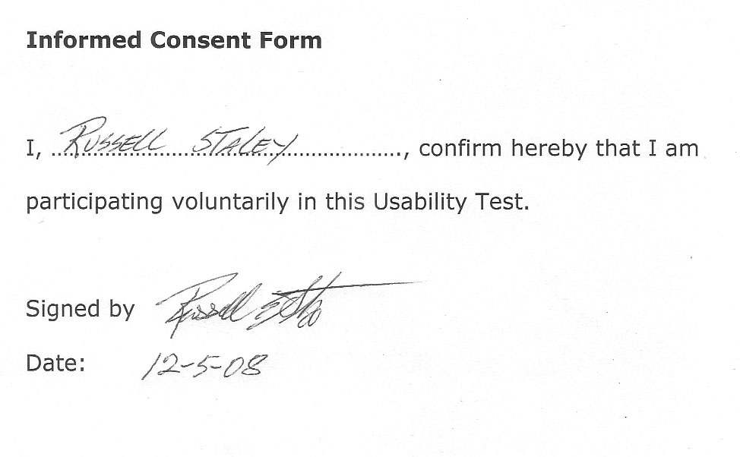
Appendix C
Informed Consent: User 2
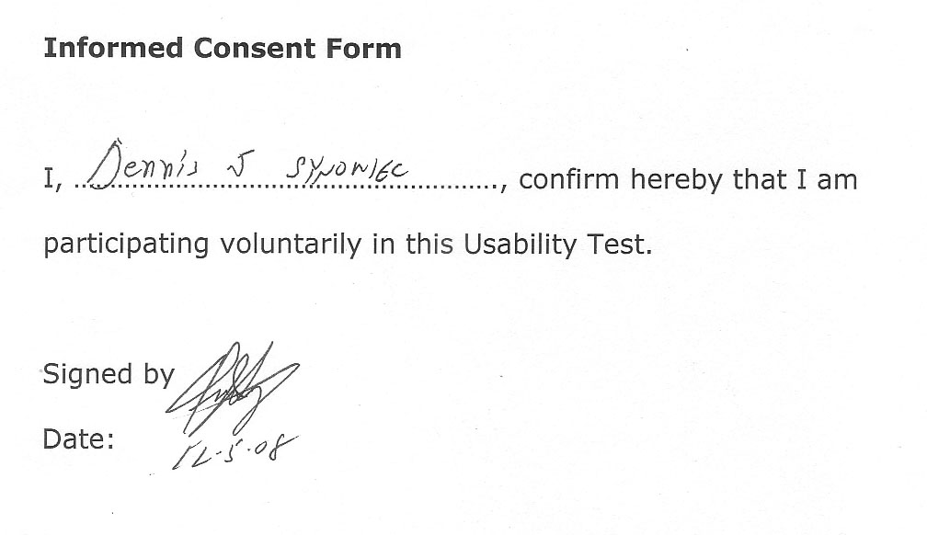
Appendix D
Informed Consent: User 3
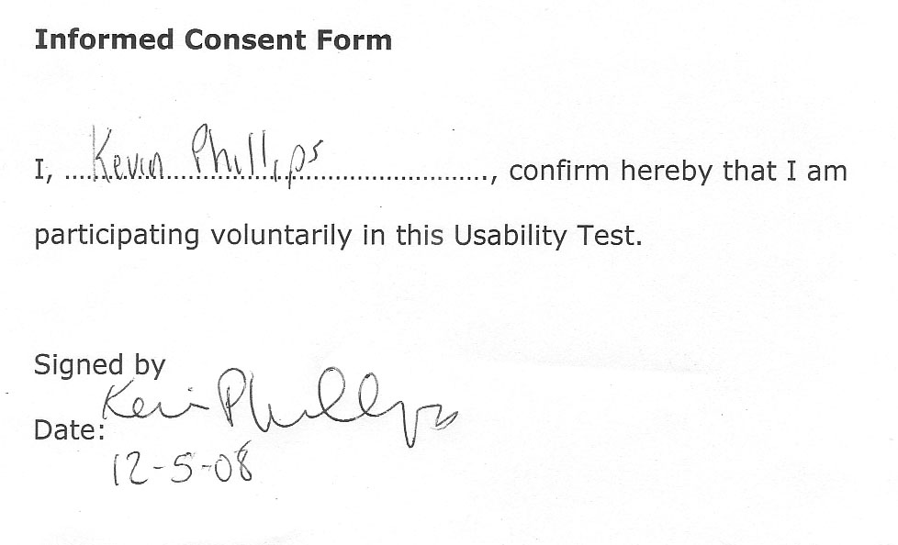
Appendix E
Pre-Usability Survey: Questions and Reponses
Q1. Please enter your age.
Answer Options | Response Average | Response Total |  | Response Count
Age: | 47 | 141 |  | 3
 |  | answered question |  | 3
 |  | skipped question |  | 0
Respondents, Ages: 55, 55, 31

Q2. How many years of computer experience do you have? (pick 1)
Answer Options | Response Percent | Response Count
0 years | 0.0% | 0
1-5 years | 33.3% | 1
6-10 years | 0.0% | 0
11-15 years | 33.3% | 1
16-20 years | 0.0% | 0
21-25 years | 0.0% | 0
26-30 years | 33.3% | 1
 | answered question | 3
 | skipped question | 0

Q3. Please rate your overall computer experience. (pick 1)
Answer Options | Response Percent | Response Count
Below Average | 33.3% | 1
Average | 66.7% | 2
Above Average | 0.0% | 0
 | answered question | 3
 | skipped question | 0

Appendix E (continued)
Pre-Usability Survey: Questions and Reponses

Q4. Please check the types of computer activity you have experienced. (Check all that apply)
Answer Options | Response Percent | Response Count
Word Processing | 66.7% | 2
Desktop Publishing | 33.3% | 1
Web Design | 0.0% | 0
E-Mail | 100.0% | 3
Social Networking | 33.3% | 1
Gaming | 66.7% | 2
Internet Searching | 100.0% | 3
Comments |  | 0
 | answered question | 3
 | skipped question | 0

Q5. Please rate your Internet skill level. (Pick 1)
Answer Options | Response Percent | Response Count
Below average | 0.0% | 0
Average | 100.0% | 3
Above Average | 0.0% | 0
 | answered question | 3
 | skipped question | 0

Q6. Choose your preferred Internet Browser. (pick 1)
Answer Options | Response Percent | Response Count
Internet Explorer (IE) | 66.7% | 2
Firefox | 33.3% | 1
 | answered question | 3
 | skipped question | 0

Appendix E (continued)
Pre-Usability Survey: Questions and Reponses

Q7. How often do you use a search engine? (pick 1)
Answer Options | Response Percent | Response Count
Daily | 66.7% | 2
A few Times per Week | 33.3% | 1
Once a Week | 0.0% | 0
A few Times per Month | 0.0% | 0
Less than 1 Time per Month | 0.0% | 0
Never | 0.0% | 0
 | answered question | 3
 | skipped question | 0

Q8. Do you prefer to search or browse for information? (pick 1)
Search: enter terms and choose from the list of results
Browse: Follow links that lead you to choices or categories and subcategories
Answer Options | Response Percent | Response Count
Search | 66.7% | 2
Browse | 33.3% | 1
 | answered question | 3
 | skipped question | 0

Q9. Please check the websites you have used: (check all that apply)
Answer Options | Response Percent | Response Count
Google | 66.7% | 2
Amazon | 33.3% | 1
Facebook | 33.3% | 1
MySpace | 100.0% | 3
MSN | 100.0% | 3
Yahoo | 100.0% | 3
Kartoo | 0.0% | 0
Grokker | 0.0% | 0
 | answered question | 3
 | skipped question | 0

Appendix E (continued)
Pre-Usability Survey: Questions and Reponses

Q10. Have you ever used the TouchGraph Browser? (pick 1)
Answer Options | Response Percent | Response Count
Yes | 0.0% | 0
No | 100.0% | 3
 | answered question | 3
 | skipped question | 0
Appendix F
User Evaluation of TouchGraph Google (Print copy provided to user)
TouchGraph Google Tasks:
- Perform a search for Kevin Bacon
- Adjust Display Settings
  - Increase Spacing; Decrease Spacing
  - Increase Zoom Level; Decrease Zoom Level
- Select Websites
  - Select Website with Hand Tool
  - Select Website with Selection Box Tool
- Launch Websites
  - Launch a Website from Graphical Display
  - Launch a Website from the Info Panel
  - Launch a Website from List
- Identify Related Website for Kevin Bacon, write down URL
- How is this website related to Kevin Bacon?
- Perform a new search for Sauk Village
- Identify a related website for Sauk Village, write down URL
- How is this website related to Sauk Village?

Appendix G
Post-Evaluation Survey about TouchGraph Google: Questions and Reponses
Q1. Please rate TouchGraph Google Browser on the criteria below:
Choose one rating per criteria."
Answer Options | 1-Poor | 2 | 3 | 4 | 5 Neutral | 6 | 7 | 8 | 9 | 10 Excellent | Response Count
Overall Ease of Use | 0 | 1 | 0 | 0 | 0 | 0 | 0 | 1 | 1 | 0 | 3
Speed of Loading | 0 | 0 | 0 | 0 | 1 | 0 | 0 | 0 | 0 | 2 | 3
Clear indication of TouchGraph working and/or finished | 1 | 0 | 0 | 0 | 0 | 0 | 0 | 1 | 1 | 0 | 3
Use of Color | 0 | 1 | 0 | 0 | 1 | 0 | 0 | 0 | 0 | 1 | 3
Ability to go back to a previous screen" | 1 | 0 | 0 | 0 | 1 | 0 | 0 | 0 | 0 | 1 | 3
Effectiveness of Tools | 0 | 0 | 1 | 0 | 1 | 0 | 0 | 0 | 0 | 1 | 3
Effectiveness of Help | 0 | 0 | 1 | 0 | 1 | 0 | 0 | 0 | 0 | 1 | 3
Ease of Navigation of Results | 0 | 1 | 0 | 0 | 0 | 0 | 0 | 1 | 1 | 0 | 3
Was this intuitive? (Easy to figure out?) | 1 | 0 | 0 | 0 | 0 | 0 | 0 | 0 | 1 | 1 | 3
 |  |  |  |  |  |  |  |  |  | answered question | 3
 |  |  |  |  |  |  |  |  |  | skipped question | 0

Q2. What did you LIKE about TouchGraph Google Browser?
Answer Options | Response Count
 | 3
answered question | 3
skipped question | 0

1, “speed”
2, “the bubble connecting the dots thing displaying the results”
3, “nothing. did not like it”

Appendix G (continued)
Post-Evaluation Survey about TouchGraph Google: Questions and Reponses

Q3. What did you DISLIKE about TouchGraph Google Browser?
Answer Options | Response Count
 | 2
answered question | 2
skipped question | 1

1, “could not copy ulr”
2,"overall thought it was easy, didnt dislike much about it"

Q4. Suggestions for improvement?
Answer Options | Response Count
 | 2
answered question | 2
skipped question | 1

1,”make ulr copiable"
2,"none"

Q5. TouchGraph Google Browser is an effective tool for browsing the Internet. (pick 1)
Answer Options | Response Percent | Response Count
TRUE | 66.7% | 2
FALSE | 33.3% | 1
 | answered question | 3
 | skipped question | 0

Appendix G (continued)
Post-Evaluation Survey about TouchGraph Google: Questions and Reponses

Q6. Indicate your agreement with the statements below.
Answer Options | 1-Do not agree | 2 | 3 | 4-Agree Completely | Response Count
It was easy to determine the relationships between the results. | 1 | 0 | 2 | 0 | 3
It was easy to visit websites listed in the graph view. | 1 | 0 | 1 | 1 | 3
It was easy to visit websites listed in the list view. | 1 | 0 | 1 | 1 | 3
The use of color made results easier to understand. | 1 | 0 | 1 | 1 | 3
 |  |  |  | answered question | 3
 |  |  |  | skipped question | 0

Q7. Will you use TouchGraph Google Browser again? (pick 1)
Answer Options | Response Percent | Response Count
Yes | 66.7% | 2
No | 33.3% | 1
 | answered question | 3
 | skipped question | 0
Appendix H
User Evaluation of TouchGraph Amazon (Print copy provided to user)
TouchGraph Amazon Tasks:
- Find related books for: Devil in the White City.
- Identify a related item, write title and price.
- How is this item related to Devil in the White City?
- Expand your selected item
- Identify another related item, write title.
- How does this item relate to Devil in the White City?
- Find related movies for: Pirates of the Caribbean
- Identify a related item, write title and price.
- How is this item related to the Pirates of the Caribbean movie?

Appendix I
Post-Evaluation Survey about TouchGraph Amazon: Questions and Reponses
Q1. Please indicate your agreement with the statements below:
Answer Options | 1-Do not agree | 2 | 3 | 4-Agree Completely | Response Count
TouchGraph Amazon Browser was easier to use due to my experience with TouchGraph Google Browser. | 0 | 1 | 1 | 1 | 3
I used skills learned in TouchGraph Google to use TouchGraph Amazon. | 0 | 0 | 2 | 1 | 3
It was easier to figure out relationships in TouchGraph Amazon | 0 | 1 | 1 | 1 | 3
 |  |  |  | answered question | 3
 |  |  |  | skipped question | 0

Q2. Please rate TouchGraph Amazon Browser on the criteria below:
Choose one rating per criteria."
Answer Options | 1-Poor | 2 | 3 | 4 | 5-Neutral | 6 | 7 | 8 | 9 | 10-Excellent | Response Count
Overall Ease of Use | 1 | 0 | 0 | 0 | 0 | 0 | 0 | 0 | 1 | 1 | 3
Speed of Loading | 1 | 0 | 0 | 0 | 0 | 0 | 0 | 0 | 1 | 1 | 3
Clear indication of TouchGraph working and/or finished | 1 | 0 | 0 | 0 | 0 | 0 | 0 | 0 | 1 | 1 | 3
Use of Color | 1 | 0 | 0 | 0 | 0 | 0 | 0 | 0 | 1 | 1 | 3
Ability to "go back" to a previous screen" | 1 | 0 | 0 | 0 | 0 | 0 | 0 | 0 | 1 | 1 | 3
Effectiveness of Tools | 0 | 1 | 0 | 0 | 1 | 0 | 0 | 0 | 0 | 1 | 3
Effectiveness of Help | 0 | 1 | 0 | 0 | 2 | 0 | 0 | 0 | 0 | 0 | 3
Ease of Navigation of Results | 0 | 1 | 0 | 0 | 0 | 0 | 0 | 0 | 1 | 1 | 3
Was this intuitive? (Easy to figure out?) | 1 | 0 | 0 | 0 | 0 | 0 | 0 | 0 | 1 | 1 | 3
 |  |  |  |  |  |  |  |  |  | answered question | 3
 |  |  |  |  |  |  |  |  |  | skipped question | 0

Appendix I (continued)
Post-Evaluation Survey about TouchGraph Amazon: Questions and Reponses

Q3. What did you LIKE about TouchGraph Amazon Browser?
Answer Options | Response Count
 | 3
answered question | 3
skipped question | 0

1,"nothing"
2,"graphics and speed"
3,"very user friendly. an untrained monkey could use it."

Q4. What did you DISLIKE about TouchGraph Amazon Browser?
Answer Options | Response Count
 | 2
answered question | 2
skipped question | 1

1,"poor navigation, not user friendly, very confusing"
2,"nothing"

Q5. Suggestions for improvement?
Answer Options | Response Count
 | 2
answered question | 2
skipped question | 1

1,"needs directions"
2,"none"

Appendix I (continued)
Post-Evaluation Survey about TouchGraph Amazon: Questions and Reponses

Q6. TouchGraph Amazon Browser is an effective tool for browsing Amazon.com. (pick 1)
Answer Options | Response Percent | Response Count
TRUE | 66.7% | 2
FALSE | 33.3% | 1
 | answered question | 3
 | skipped question | 0

Q7. Indicate your agreement with the statements below.
Answer Options | 1-Do not agree | 2 | 3 | 4-Agree Completely | Response Count
It was easy to determine the relationships between the results. | 1 | 0 | 0 | 2 | 3
It was easy to view items listed in the graph view. | 1 | 0 | 0 | 2 | 3
It was easy to view items listed in the list view. | 1 | 0 | 0 | 2 | 3
The use of color made results easier to understand. | 1 | 0 | 1 | 1 | 3
Additional information provided (such as item price) was useful. | 0 | 0 | 1 | 2 | 3
 |  |  |  | answered question | 3
 |  |  |  | skipped question | 0

Q8. Will you use TouchGraph Amazon Browser again? (pick 1)
Answer Options | Response Percent | Response Count
Yes | 66.7% | 2
No | 33.3% | 1
 | answered question | 3
 | skipped question | 0
Appendix J
Evaluation Form: User 1
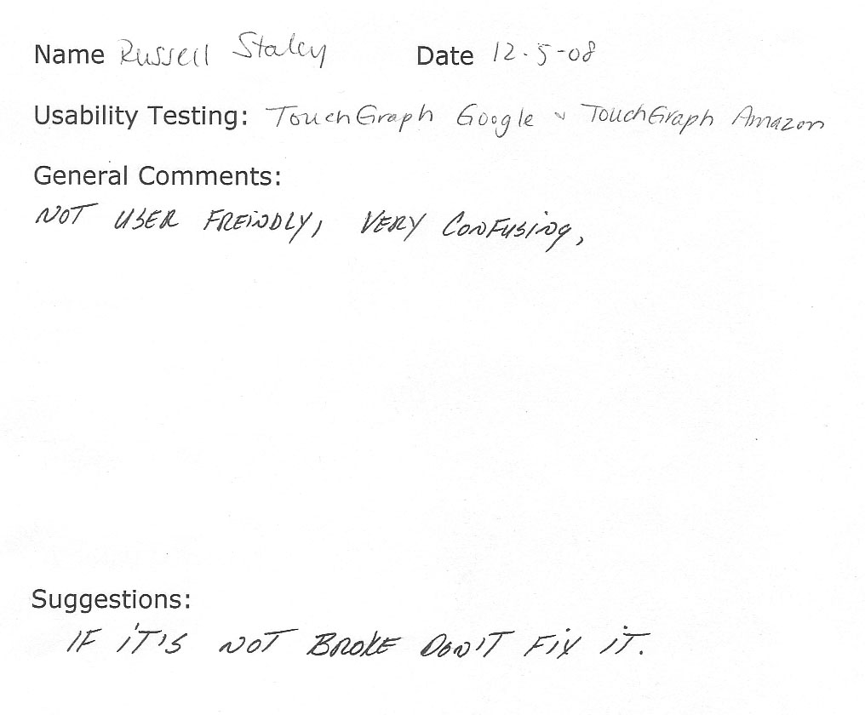
Appendix K
Evaluation Form: User 2
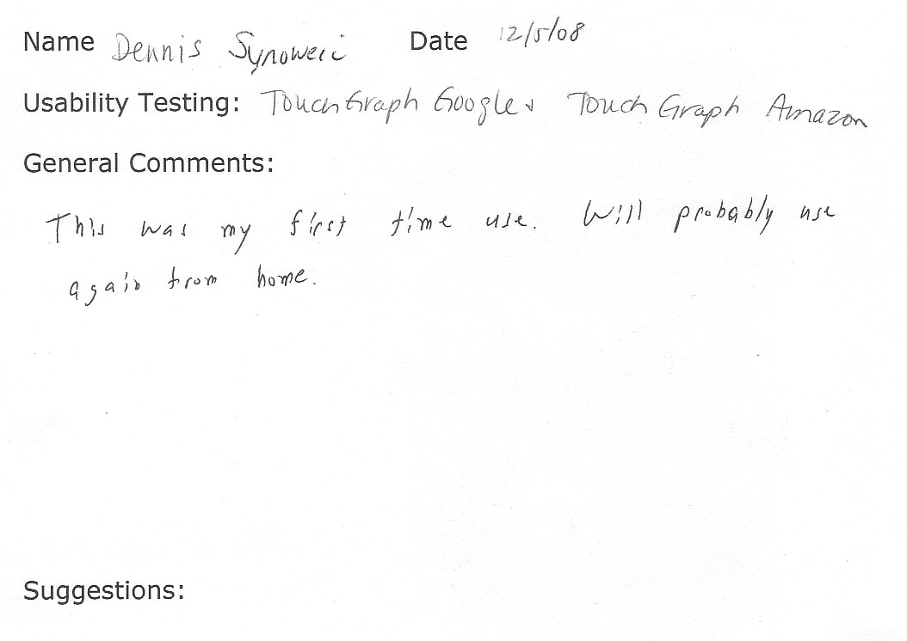

Appendix L
Evaluation Form: User 3
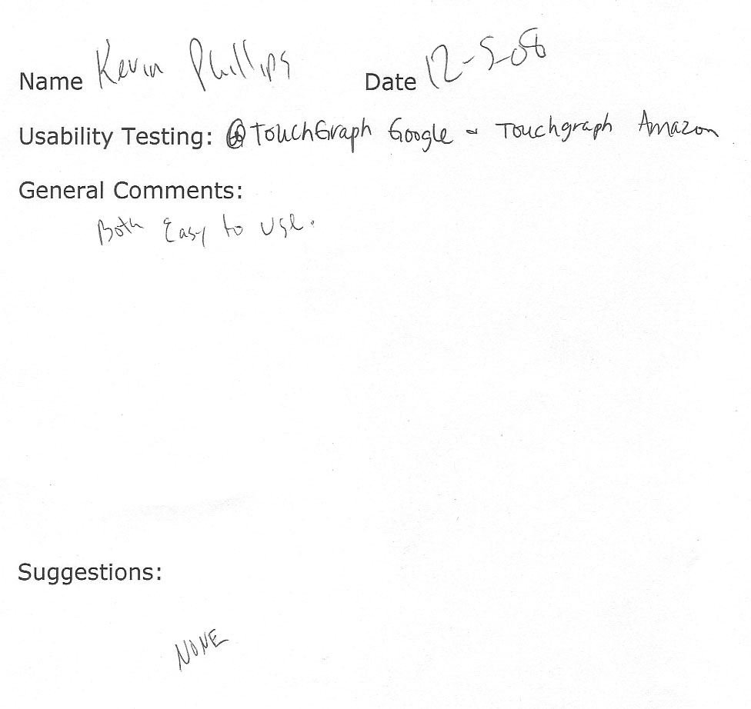
References:
Hudson, W. (2001). How many users does it take to change a Web site?. ACM SIGCHI
Bulletin - a supplement to interactions, 2001, Retrieved December 14, 2008, from
http://doi.acm.org.proxy.libraries.rutgers.edu/10.1145/967222.967230
Nielsen, J. (2005). Heuristics for user interface design. Retrieved November 28, 2008,
from http://www.useit.com/papers/heuristic/heuristic_list.html
Reeb, B. (2007, April). LITA Regional Institute: User Centered Design: Usability. LITA
Regional Institute held at Galther Health Library, Chicago.
TouchGraph: Products: Amazon Browser. Retrieved, November 30, 2008, from
http://www.touchgraph.com/TGAmazonBrowser.html
TouchGraph: Products: Google Browser. Retrieved, November 30, 2008, from
http://www.touchgraph.com/TGGoogleBrowser.html

